Enrollment System (ES) 4.3

Release Notes



April 2016

Department of Veterans Affairs

Office of Information and Technology (OI&T)

Table of Contents

1 Introduction 1

2 Purpose 1

3 Audience 1

4 ES 4.3 Release 1

4.1 New Features and Functions 1

4.2 Enhancements and Modifications to Existing 2

4.2.1 Affordable Care Act (ACA) Reporting 2

4.2.1.1 IRS Reject Management 2

4.2.1.2 Rejected Person Submissions 3

4.2.1.3 Submit Corrections 3

4.2.1.4 Reporting Minimum Essential Coverage (MEC) to the IRS 4

4.2.1.5 IRS Transmissions 5

4.2.1.6 Viewing IRS Reporting Results 5

4.3 Known Issues 5

4.4 Product Documentation 5

# Introduction

The Department of Veterans Affairs (VA) is obligated to support the Patient Protection and Affordable Care Act (PPACA). Effective January 1, 2014, the Affordable Care Act (ACA) requires every individual taxpayer in the United States to maintain minimum essential healthcare coverage or face a tax penalty. Enrollment in Veterans health care meets the Minimum Essential Coverage (MEC) threshold under 26 Code of Federal Regulations (CFR) 1.36B-2 (c)(2)(ii) of the Treasury Notice of Proposed Rulemaking (NPRM).

The VA is required to provide the IRS with a list or file containing information on every Veteran and beneficiary that obtained MEC through the VA for a tax year. The information provided to the IRS includes: name, address, DOB, insurer information (VA information, Part III of the 1095B), and either a full year or number of months the VA provided MEC. Section 6055(a) requires every entity that provides MEC, to file annual returns reporting information for each individual for whom coverage is provided. The Veterans Letter, 1095B form, or equivalent communication, must be prepared annually for the prior tax year and filed with the IRS.

# Purpose

These release notes cover the changes to ES 4.3 for the ACA Inc 4 release.

# Audience

This document targets users and administrators of ES 4.3 and applies to the changes made between this release and any previous release for this software.

# ES 4.3 Release

The following sections provide a summary of the new features and functions added, enhancements and modifications to the existing software, and any known issue for ES 4.3.

## New Features and Functions

The following are the new features and functions for the ES 4.3 release.

* Allows for the identification of Veterans for whom to issue an annual Minimum Essential Coverage (MEC) letter and IRS Form 1095B. (Claims Processing and Eligibility (CPE) identifies the beneficiaries.)
* Allows for the determination of the MEC for the previous calendar year for individuals, to populate the IRS Form 1095B.
* Establishes the connection between the ES and the IRS to securely share MEC information, e.g., IRS Form 1095B.
* Allows for ES to receive and store an acknowledgement from the IRS for receipt of IRS Form 1095B.
* Allows ES users to view, correct, and retransmit MEC information to the IRS on behalf of the Veterans.
* Allows ES users to complete a corrected IRS Form 1095B for Veterans and to issue an annual MEC Letter, IRS Form 1095B, and MEC Report, and to share with the IRS. (Claims Processing and Eligibility (CPE) must correct IRS Form 1095B for the beneficiaries.)

## Enhancements and Modifications to Existing

### Affordable Care Act (ACA) Reporting

In April 2016, the Veterans Health Administration (VHA) was mandated by legislation to report Minimum Essential Coverage (MEC) periods to the Internal Revenue Service (IRS) for all Veterans and Beneficiaries that were provided healthcare benefits in the previous tax year.

#### IRS Reject Management

New option under the Admin menu: IRS Reject Management, used to manage IRS rejections.

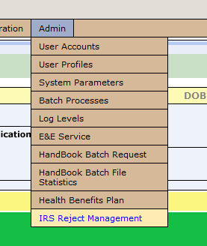

Admin>IRS Reject Management

On the IRS Reject Management page, there are two tabs: Person Submissions, which is a list of individual Veteran submissions that were rejected by the IRS, due to an error in the data submission and Batch Submissions, which is a list of batch submissions (transmission containing many individual submissions) that failed or were rejected.

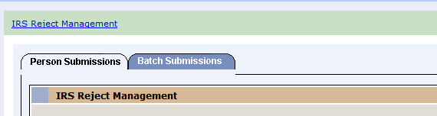

IRS Reject Management>Person Submissions or   
Batch Submissions>IRS Reject Management

#### Rejected Person Submissions

The IRS Reject Management page displays with a VPID link to search for and access a Veteran’s record and an Error Reason, a column for the descriptions of the error messages returned by the IRS or of the errors that must be corrected on the Veteran’s record prior to resubmitting the transmission.

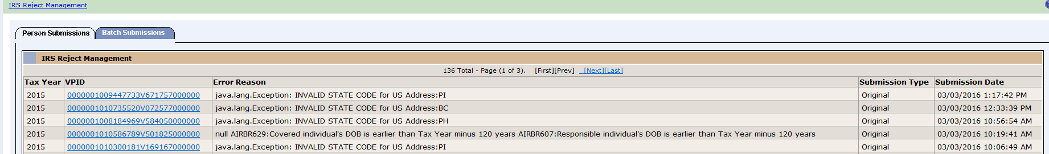

IRS Reject Management>Person Submissions>IRS Reject Management

#### Submit Corrections

A correction is the submission of a new 1095B form for a Veteran, when the original submission is rejected for data errors or where the coverage period is reported erroneously by the system.

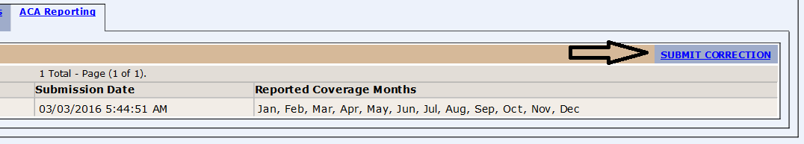

Communications tab>ACA Reporting sub tab>SUBMIT CORRECTION link

The Submit Corrected IRS 1095B Coverage Data form displays the Tax Year, Address, and Coverage Months that were transmitted to the IRS. From this screen, the user has the ability to edit this information and then submit it as a correction to the Original submission for the tax year.

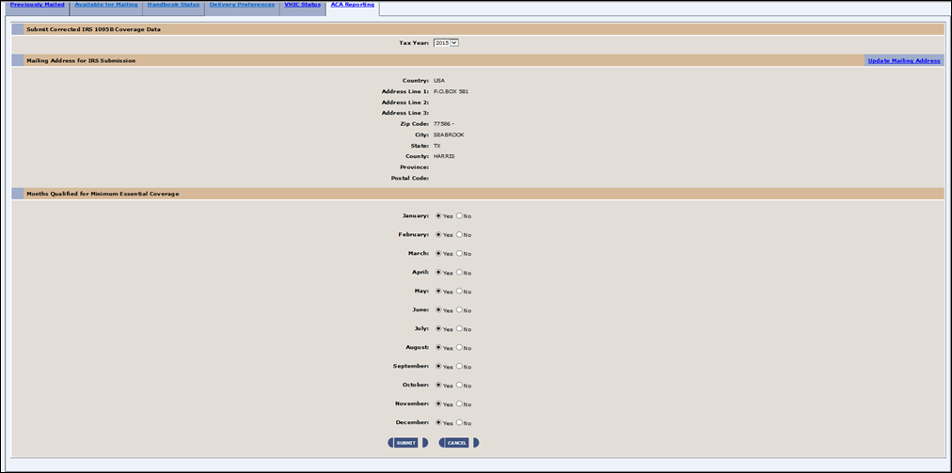

ACA Reporting sub tab>Submit Corrected IRS 1095B Coverage Data

In the ACA Reporting sub tab, to indicate a successful submission, the page displays a green banner with the corrected transmission in a Processing status in the Reporting table.

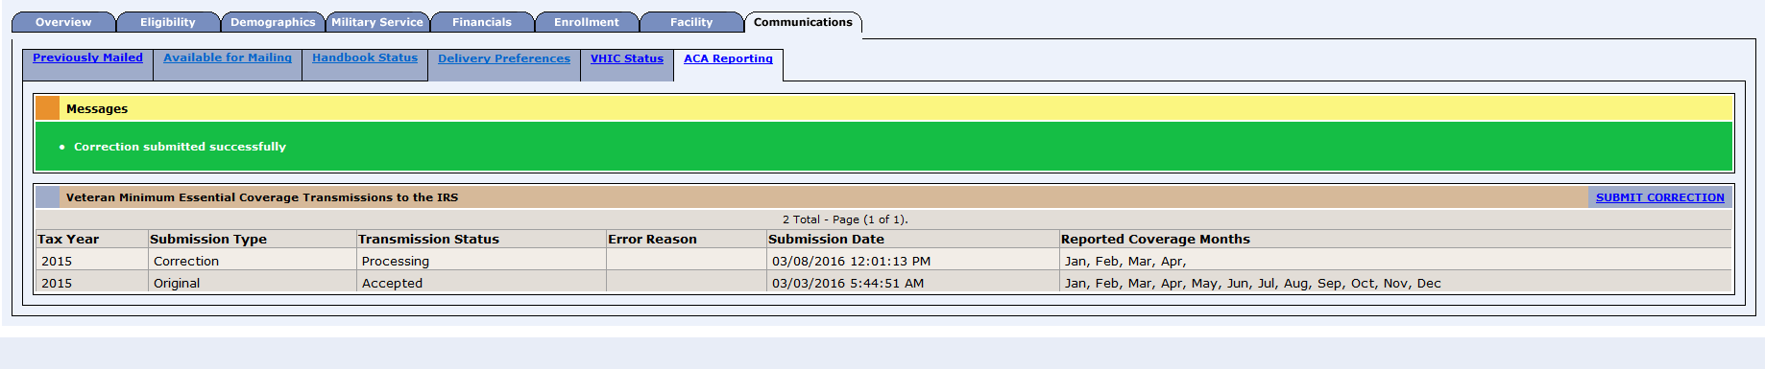

Communications tab>ACA Reporting sub tab>Messages

#### Reporting Minimum Essential Coverage (MEC) to the IRS

The reporting functionality is via electronic Web service submissions from the Enrollment System (ES) to the service provided by the IRS for the purpose of reporting ACA MEC.

#### IRS Transmissions

* ES automatically selects all qualified Veterans and transmits the original submissions to the IRS, via ES background batch processes.
* No end user involvement is required to transmit the population of all the Veteran records.
* Individual transmission records are available to view and correct as they are completed. There is no need to wait for all of the processing to be completed.

#### Viewing IRS Reporting Results

The ACA Reporting sub tab contains the **Veteran Minimum Essential Coverage Transmissions to the IRS** (form) with the SUBMIT CORRECTION link.

The form displays the Tax Year, Submission Type, Transmission Status, Error Reason, Submission Date, and Reported Coverage Months.

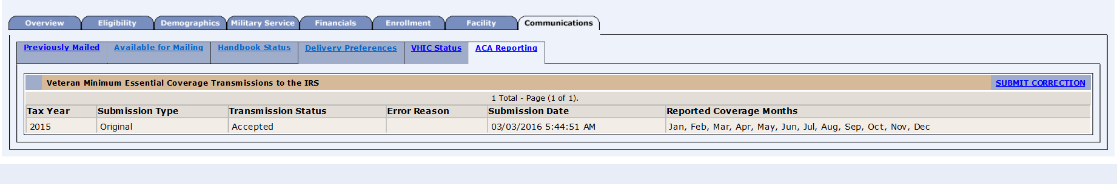

Person Search>Communication Log>Communications tab>ACA Reporting sub tab

## Known Issues

There are no known issues specific to this release.

## Product Documentation

The following documents apply to this release.

ES 4.3 User Guide is uploaded to the [VA Software Document Library](http://www.va.gov/vdl/) (VDL)

Additional reference documentation related to the ACA release is stored in Rational Team Concert and in the Project Notebook on the [ACA TSPR](http://tspr.vista.med.va.gov/warboard/anotebk.asp?proj=1629&Type=Active)

* ES 4.3 Developer’s Guide
* ES 4.3 Installation Guide
* ES 4.3 Production Operations Manual